- Define arbitrary shape pad
- Open footprint
- Add a pad
- Add an arbitrary shape
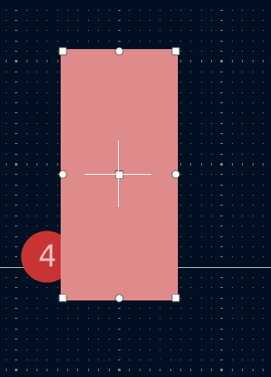
- Edit the pad as graphic shapes
- Put the arbitrary shape on the top of the pad
- Press Ctrl+E again to exit. Then we get an arbitrary pad where two shape combined together.
